Business Proposal
Vida e Cafè Website Redesign
Subject: Web Development (WEBE5020)
Full Name: Saaheerah Majiet
Student Number: ST10516777
Group: 1

1. Organisation Overview
Vida e Cafè was established in South Africa and has since evolved into a global franchise. The business focuses on offering customers throughout cities rapid assistance and excellent coffee. The company’s vibrant atmosphere and convenient takeout options have helped it gain widespread popularity.

Mission and Vision Statement
Vida e Cafè aims to be an outstanding coffee brand known for quality, reliability, and strong customer relationships.

Target Audience
The website targets the following groups:
- Workers and business professionals who need urgent, high-quality coffee
- Scholars and students seeking a comfortable environment
- Coffee lovers looking for premium, convenient options

2. Website Goals and Objectives
The goals of the website are to increase customer engagement and promote the business effectively.

Goals
- Increase awareness of the brand
- Display items on the menu clearly
- Provide branch addresses and contact information

Key Performance Indicators (KPIs)
- Increase in website traffic and exposure
- Growth in online customer engagement
- Measurable increase in in-store visits

3. Current Website Analysis
Strengths of the current website include clear menu information and effective advertising. However, user interaction and responsiveness on mobile devices require significant improvement.

Weaknesses
- Few interactive elements for users
- Navigation could be simplified and improved
- Limited mobile responsiveness

Improvements
- Incorporate online ordering options
- Improve the customer experience on mobile devices
- Add interactive elements such as a store locator and FAQ section

4. Proposed Website Features and Functionality

Website Features
The website includes the following key pages:
- Homepage: Provides an overview of the brand, promotions, and featured products
- About Page: Shares the history, mission, and background of the organisation
- Products Page: Displays available products including coffee, beverages, and snacks
- Store Locator: Helps users find nearby branches with Google Maps integration
- Contact Page: Provides contact information and enquiry options
- Enquiry Page: Allows customers to submit orders, questions, or feedback

Website Functionality
The website includes the following functional elements:
- A responsive navigation menu allowing easy movement between pages
- A cart system enabling users to add and track their orders
- Product search and filter functionality
- An FAQ accordion for instant answers to common questions
- Contact and enquiry form validation with user feedback messages
- Image lightbox for product viewing
- Scroll-based reveal animations for cards and content
- CSS animations including steam effects and gradient movement

5. Design and User Experience

Colour Scheme
The colours red, white, and black form the preferred colour scheme. These colours give the cafè a bright, vibrant, and modern look while reflecting its brand identity. White and black create contrast and enhance visual appeal, while red draws attention to important features such as call-to-action buttons.

Typography
Simple and modern sans-serif fonts (Lato) and display fonts (Playfair Display) are applied throughout the site. Headings are larger and bolder to provide a clear structure, while body text is smaller and easier to read. This keeps the design consistent and makes content accessible across all pages.

Layout and Design
A structured and simple design approach is used for the layout. Information is organised into separate sections using consistent spacing. Images and promotional content are used as standard visual elements to improve overall appearance and attract visitors.

User Experience Considerations
Customer experience is the top priority. Users can navigate easily with a clear, straightforward menu layout. The responsive structure ensures the website appears correctly on various devices including smartphones, tablets, and desktops. The selected typography and colour scheme further improve usability and readability.

6. Technical Requirements

Hosting and Domain Requirements
- Domain: vidaecaffee.netlify.app (deployed via Netlify)
- Hosting: Netlify managed hosting – uses outsourced infrastructure for server maintenance, security patching, and scaling
- Security: SSL/TLS certificates (HTTPS) – protects sensitive data by encrypting data transferred between the browser and server
- Availability: 99.9% uptime SLA – provides constant brand accessibility
- Technologies: HTML5, CSS3, JavaScript (Vanilla)
- Version Control: GitHub (repository managed by Cutiepie2007)

7. Timeline and Milestones
The following table outlines the project phases and their corresponding timelines:

Phase | Timeline | Focus Area
Part 1: Submission | Due: 20th April | Planning & Design (project brief, research, sitemap, and wireframe)
Interim Phase | 21st April – 10th May | Development (writing HTML, CSS, JS, and building assets)
Part 2: Pre-submission | 11th May – 20th May | Testing (testing across browsers and devices)
Part 2: Submission | Due: 29th May | Final Submission (finalise code and project files)

8. Budget
The estimated budget for the website is based on basic development and hosting needs:
- Domain name: R100 – R200 per year
- Web hosting (Netlify free tier): R0 – free for basic deployment
- Development tools (VS Code, GitHub): Free
- Images and resources: Free (using royalty-free platforms such as Unsplash and Pexels)
Total estimated cost: R100 – R200 per year
This budget is affordable and suitable for a small-scale student website project. Costs may increase in future if premium hosting or a custom domain is required.

9. Research
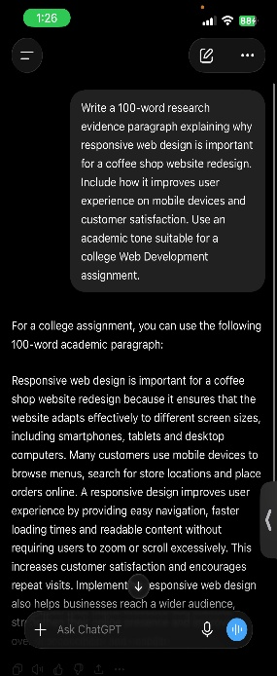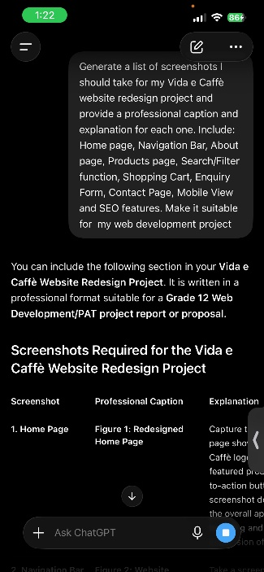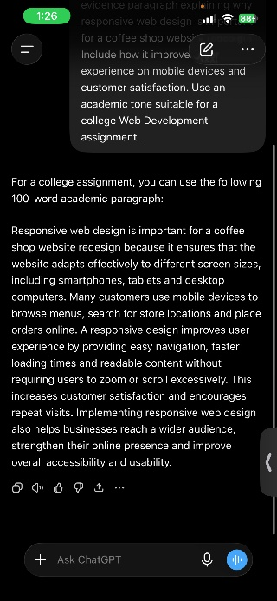

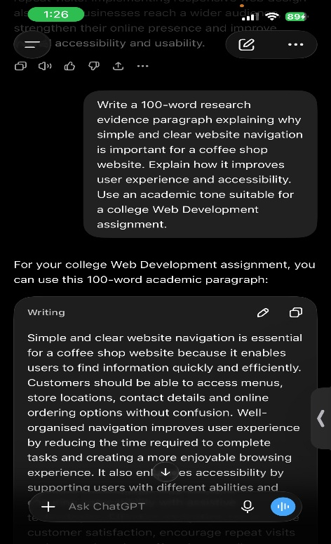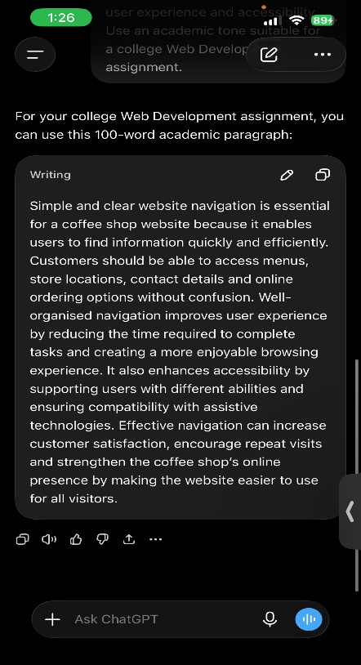

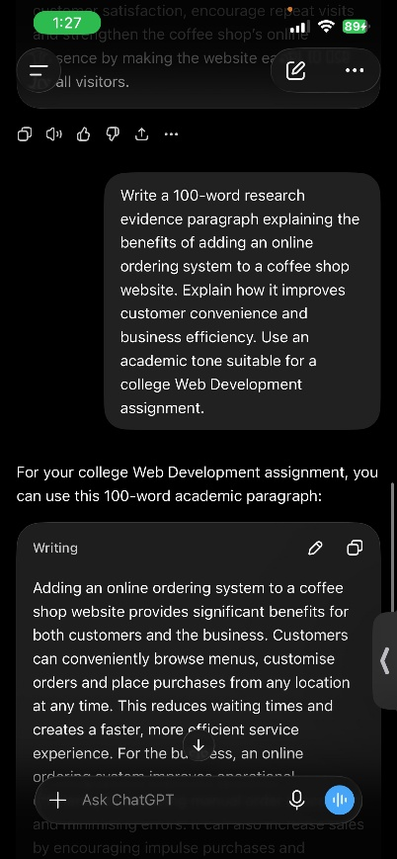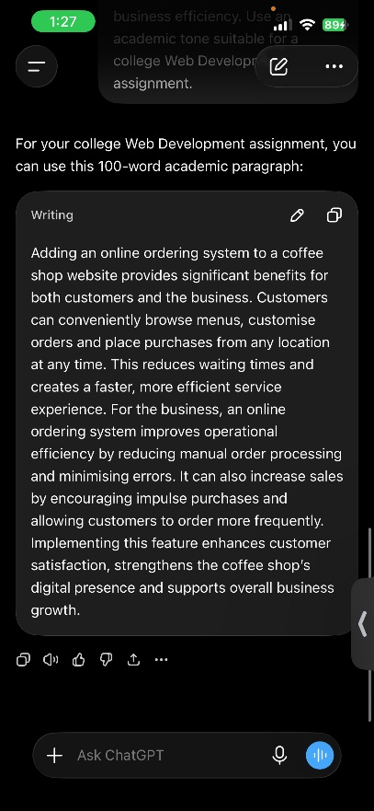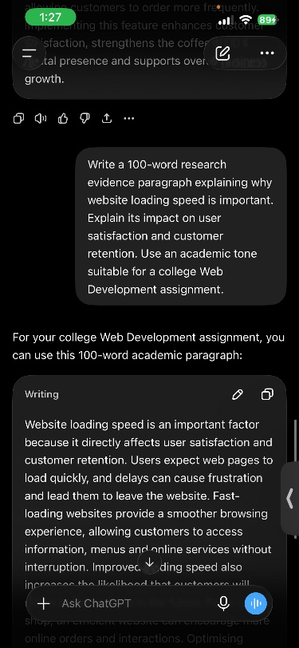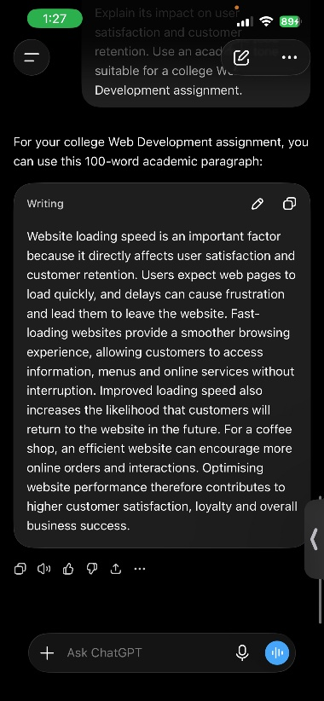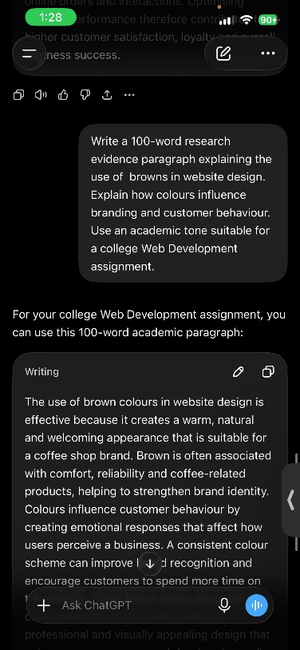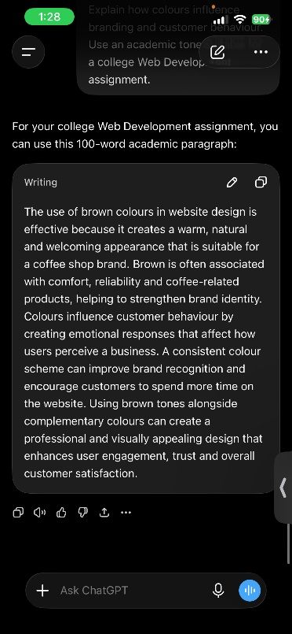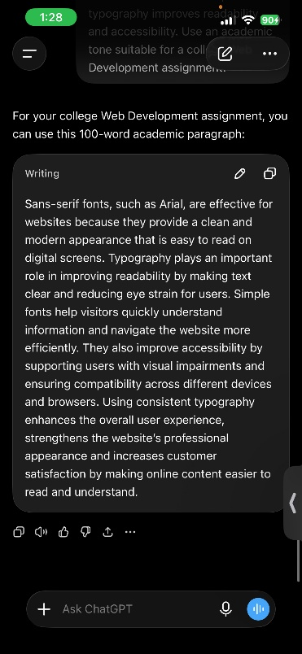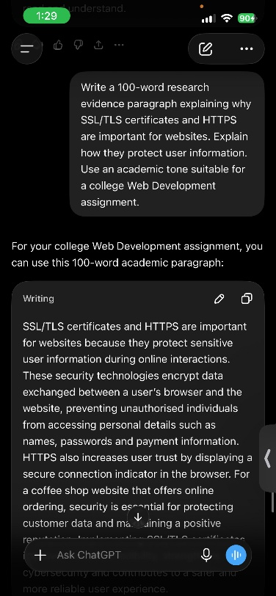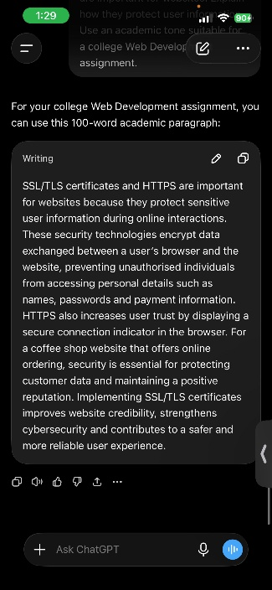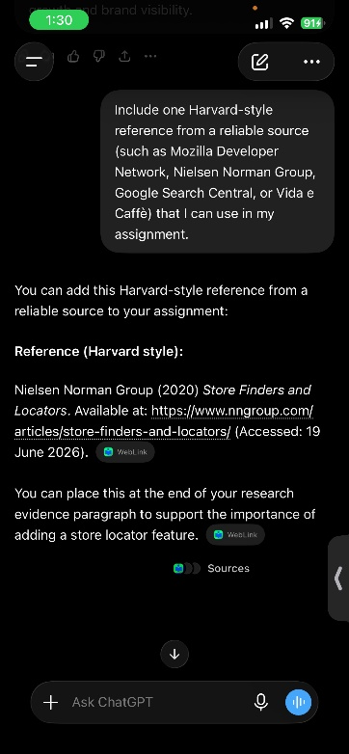

10. References
Duckett, J., 2011. HTML and CSS: Design and Build Websites. Indianapolis: Wiley.
Mozilla Developer Network, 2025. HTML, CSS and JavaScript Guide. Available at: https://developer.mozilla.org [Accessed: 20 April 2026].
W3Schools, 2025. Web Development Tutorials. Available at: https://www.w3schools.com [Accessed: 20 April 2026].
Unsplash, 2025. Free stock images. Available at: https://unsplash.com [Accessed: 20 April 2026].
Pexels, 2025. Free stock photos. Available at: https://www.pexels.com [Accessed: 20 April 2026].
Pixabay, 2025. Free images and royalty-free stock. Available at: https://pixabay.com [Accessed: 20 April 2026].
Vida e Cafè, 2026. Official Website. Available at: https://www.vidaecaffe.com [Accessed: 20 April 2026].
Register Domain SA, 2025. Understanding the costs of domain registration and hosting in South Africa. Available at: https://www.registerdomain.co.za/blog/domain-hosting-costs-south-africa/ [Accessed: 19 June 2026].
Nielsen Norman Group, 2024. How Users Read on the Web. Available at: https://www.nngroup.com [Accessed: 19 June 2026].
ChatGPT, 2026. ChatGPT (April version). Available at: https://chat.openai.com [Accessed: 20 April 2026].
QuillBot, 2026. QuillBot Paraphrasing Tool. Available at: https://quillbot.com [Accessed: 20 April 2026].

